MODEL:JW-C40-60440V |1800rpm | 60Hz

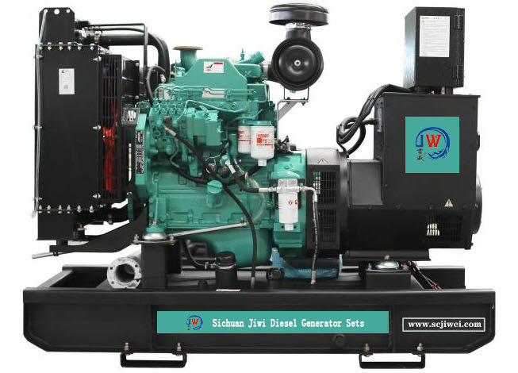

ESP  StandbyPower | 50kVA | PRP  PrimePower | 45kVA
ENGINE | DCECCummins | ALTERNATOR | STAMFORD
ENGINE | 4BT3.9-G2 | ALTERNATOR | S1L2-N1

GENERALFEATURES
Engine:DCECCummins 4BT3.9-G2 | Alternator: singlebearing,IP23,insulationclassH
50℃ radiator, fansaredrivenbybelt, withsafetyguard | Drytypeairfilter, fuelfilter&oilfilter
Vibration damper | Standard controlpanel
24V chargingalternator | Exhaustbellows, elbows, flange &muffler
Lead-acidbatteries,rack and cables | Usermanual

MODEL:JW-C40-60440V |1800rpm | 60Hz

GENERATORRATINGS
StandbyAmps
StandbyRatings
(kW /kVA)
PrimeRatings(kW /kVA)
PF
（COSΦ)
480/27760 3 0.8 60 40kW/50kVA 36kW/45kVA
460/26660 3 0.8 63 40kW/50kVA 36kW/45kVA
440/25460 3 0.8 66 40kW/50kVA 36kW/45kVA
416/24060 3 0.8 69 40kW/50kVA 36kW/45kVA
VoltageHzPhase

PrimePower (PRP):Prime power is available for anunlimitednumberofannualhoursinvariableloadapplication,inaccordancewithGB/T2820（eqvISO 8528）;A 10% overloadcapabilityisavailableforaperiodof1hourwithin a12-hourperiodofoperation.
StandbyPowerRating(ESP):Thestandbypowerratingisapplicableforsupplyingemergencypowerforthedurationofautilitypowerinterruption.Nooverload,utilityparallelornegotiatedoutageoperationcapabilityisavailable atthisrating.

SALESPROMISES

JiweiPowerprovides a fullline of brandnew andhighqualityproducts.Eachandeveryunitis strictlyfactorytested.
Warrantyis according to our standard conditions:15months from thedateJIWEI sold tothefirstbuyeroroneyearafterinstallationor1000runninghours(accumulated),whichevercomesfirst.
Service andparts are available fromJiweiPower or distributorsinyourlocation.

MODEL:JW-C40-60440V |1800rpm | 60Hz

ENGINESPECIFICATION
Manufacturer /Model | DCECCummins 4BT3.9-G2
Airintake system | Turbocharged,
Fuel system | A type fuelpump
Cylinder arrangement | 4inline
Displacement | 3.9L
Bore andstroke | 102×120mm
Compressionratio | 18
Rated speed | 1800rpm
Max. Standbypower atratedspeed | 44kW
Governor type | Electronic

Exhaust System
Exhaust gas flow | 6.4m3/min
Exhaust temperature | 373°C
Maxbackpressure | 10kPa
Air IntakeSystem
Maxintakerestriction | 6.2kPa
Combustion air flow | 3.3m3/min
Air flowrequired for radiator | 120m3/min

MODEL:JW-C40-60440V |1800rpm | 60Hz

Fuel System
Fuelconsumption@100%(PrimePower)Load | 221g/kWh | 10.9L/h
Fuelconsumption@ 75%(PrimePower)Load | 230g/kWh | 8.6L/h
Fuelconsumption@ 50%(PrimePower)Load | 255g/kWh | 6.6L/h

OilSystem
Total oilcapacity | 11L
Oil sumpcapacity | 8.5~9.5L
Cooling System
Coolant capacity | 19L
Max water temperature | 104°C

MODEL:JW-C40-60440V |1800rpm | 60Hz

ALTERNATORSPECIFICATION
IndustrialalternatorsmeettherequirementsoftherelevantpartsoftheBS5000, VDE0530,NEMAMG1-22,IEC34, CSA 22.2-100 andAS1359.
Alternator Data
Number ofPhase | 3
Connecting Type | 3Phaseand 4 Wires, Ytypeconnecting
Number of Bearing | 1
PowerFactor | 0.8
Protection Class | IP23
Altitude | ≤1000m
Exciter Type | Brushless exciting
InsulationClass/TemperatureRise | H/H
TelephoneInfluenceFactor(TIF) | ＜50
THF | ＜2%
Alternator Capacity | 50.4kVA
Alternator Efficiency | 90.0%

MODEL:JW-C40-60440V |1800rpm | 60Hz

GENERATINGSETDATA
Relatedrange of voltage setting | ≥±5%
Steady-state voltage deviation | ≤±1%
Transientvoltagedeviation(100 % suddenpower decrease) | ≤+25%
Transient voltage deviation(suddenpowerincrease) | ≤-20%
Voltagerecoverytime (100% suddenpowerdecrease) | ≤6S
Voltagerecovery time (suddenpowerincrease) | ≤6S
Relatedrange of frequency setting | 0-5% adjustable
Steady-state frequencyband | ≤1.5%
Transientfrequencydeviation(100 % suddenpower decrease) | ≤+12%
Transient frequency deviation(suddenpowerincrease) | ≤-10%
Frequencyrecoverytime(100 % suddenpower decrease) | ≤5S
Frequencyrecovery time (suddenpowerincrease) | ≤5S

STANDARDFEATURES
Standard auto controlsystem | Exhaust system(includinguntilmuffler) | Documents
Oil drainvalve | Startingbatteries (maintenance-free& watering-free) with connective  wires | MCCB
Base fueltank

MODEL:JW-C40-60440V |1800rpm | 60Hz

OPTIONS
Daily fueltank | Rainproof type | Remote controlpanel
Alternator heater | Soundproof type | Paralleling system
Spareparts | Trailer type | Switchbox
Automatic transfer switch

DIMENSIONS&WEIGHT
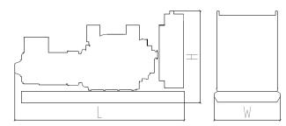 | Standard Configuration (open type)
 | OverallDimensions:1750×770×1370mm
 | Weight:900kg
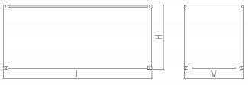 | Soundproof Type
 | OverallDimensions: 2290×1060×1680mm
 | Weight:1350kg

Specifications are subject to changewithoutnotice.

Sichuan Jiweicheng Electric Power Equipment Co., LTD.
Website :www.scjiwei.com
Whatsapp/WeChat:+86 18981714166
https://scjiwei.en.alibaba.com
Email :jiwei166@scjiwei.com
Address: Building 7, Chengnan Tianfu Wisdom Garden, Pengshan District, Meishan City, Sichuan Province

