MODEL:JW-C275Q400V |1500rpm |50Hz
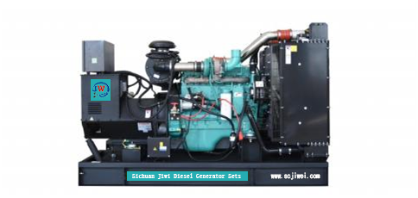

ESP  StandbyPower | 275kVA | PRP  PrimePower | 250kVA
ENGINE | DCECCummins | ALTERNATOR | STAMFORD
ENGINE | QSL8.9-G4 | ALTERNATOR | UCDI274K1

GENERALFEATURES
Engine:DCECCumminsQSL8.9-G4 | Alternator: singlebearing,IP23,insulationclassH
50℃ radiator, fansaredrivenbybelt, withsafetyguard | Drytypeairfilter, fuelfilter&oilfilter
Vibration damper | Standard controlpanel
24V chargingalternator | Exhaustbellows, elbows, flange &muffler
Lead-acidbatteries,rack and cables | Usermanual

MODEL:JW-C275Q400V |1500rpm |50Hz

GENERATORRATINGS
PF
（COSΦ)
StandbyAmps
StandbyRatings
(kW /kVA)
Voltage
Hz
Phase
440/254 5030.8 361 220/275 200/250
415/240 5030.8 383 220/275 200/250
400/230 5030.8 397 220/275 200/250
380/2205030.8 418 220/275 200/250
PrimeRatings(kW /kVA)

PrimePower (PRP):Prime power is available for anunlimitednumberofannualhoursinvariableloadapplication,inaccordancewithGB/T2820（eqvISO 8528）;A 10% overloadcapabilityisavailableforaperiodof1hourwithin a12-hourperiodofoperation.
StandbyPowerRating(ESP):Thestandbypowerratingisapplicableforsupplyingemergencypowerforthedurationofautilitypowerinterruption.Nooverload,utilityparallelornegotiatedoutageoperationcapabilityisavailable atthisrating.

SALESPROMISES

JiweiPowerprovides a fullline of brandnew andhighqualityproducts.Eachandeveryunitis strictlyfactorytested.
Warrantyis according to our standard conditions:15months from thedateJIWEI sold tothefirstbuyeroroneyearafterinstallationor1000runninghours(accumulated),whichevercomesfirst.
Service andparts are available fromJiweiPower or distributorsinyourlocation.

MODEL:JW-C275Q400V |1500rpm |50Hz

ENGINESPECIFICATION
Manufacturer /Model | CumminsQSL8.9-G4
Airintake system | Turbocharged & Air-airintercooling
Fuel system | Commonrail
Cylinder arrangement | 6inline
Displacement | 8.9L
Bore andstroke | 114×144.5mm
Compressionratio | 17.73
Rated speed | 1500rpm
Max. Standbypower atratedspeed | 258kW/346hp
Governor type | Electronic

Exhaust System
Exhaust gas flow | 38.1m3/min
Exhaust temperature | 559℃
Maxbackpressure | 10kPa
Air IntakeSystem
Maxintakerestriction | 6.2kPa
Combustion air flow | 18.8m3/min
Air flowrequired for radiator | 327m3/min

MODEL:JW-C275Q400V |1500rpm |50Hz

Fuel System
Fuelconsumption@100%(PrimePower)Load | 210 g/kWh | 55.3L/h
Fuelconsumption@ 75%(PrimePower)Load | 237 g/kWh | 47.0L/h
Fuelconsumption@ 50%(PrimePower)Load | 246 g/kWh | 33.3L/h

OilSystem
Total oilcapacity | 24L
Oil consumption | ≤4g/kwh
Oil sumpcapacity | 23.4L

Cooling System
Coolant capacity | 57L
Max water temperature | 104℃

MODEL:JW-C275Q400V |1500rpm |50Hz

ALTERNATORSPECIFICATION
IndustrialalternatorsmeettherequirementsoftherelevantpartsoftheBS5000, VDE0530,NEMAMG1-22,IEC34, CSA 22.2-100 andAS1359.
Number ofPhase | 3
Connecting Type | 3Phaseand 4 Wires, Ytypeconnecting
Number of Bearing | 1
PowerFactor | 0.8
Protection Class | IP23
Altitude | ≤1000m
Exciter Type | Brushless exciting
InsulationClass/TemperatureRise | H/H
TelephoneInfluenceFactor(TIF) | ＜50
THF | ＜2%
Alternator Capacity | 250kVA
Alternator Efficiency | 92.7%

MODEL:JW-C275Q400V |1500rpm |50Hz

GENERATINGSETDATA
Relatedrange of voltage setting | ≥±5%
Steady-state voltage deviation | ≤±1%
Transientvoltagedeviation(100 % suddenpower decrease) | ≤+20%
Transient voltage deviation(suddenpowerincrease) | ≤-15%
Voltagerecoverytime (100% suddenpowerdecrease) | ≤4S
Voltagerecovery time (suddenpowerincrease) | ≤4S
Relatedrange of frequency setting | 0-5% adjustable
Steady-state frequencyband | ≤0.5%
Transientfrequencydeviation(100 % suddenpower decrease) | ≤+10%
Transient frequency deviation(suddenpowerincrease) | ≤-7%
Frequencyrecoverytime(100 % suddenpower decrease) | ≤3S
Frequencyrecovery time (suddenpowerincrease) | ≤3S

STANDARDFEATURES
Standard auto controlsystem | Exhaust system(includinguntilmuffler) | Documents
Oil drainvalve | Startingbatteries (maintenance-free& watering-free) with connective  wires | Special tools
Base fueltank | MCCB

MODEL:JW-C275Q400V |1500rpm |50Hz

OPTIONS
Daily fueltank | Rainproof type | Remote controlpanel
Alternator heater | Soundproof type | Paralleling system
Spareparts | Trailer type | Switchbox
Automatic transfer switch

DIMENSIONS&WEIGHT
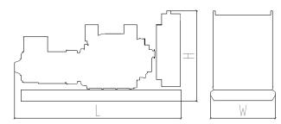 | Standard Configuration (open type withbasefueltank)
 | OverallDimensions: 2750×1100×1700mm
 | Weight: 2100kg
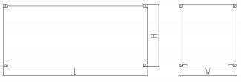 | Soundproof Type
 | OverallDimensions: 3590×1310×2050mm
 | Weight: 3000kg

Specifications are subject to changewithoutnotice.

Sichuan Jiweicheng Electric Power Equipment Co., LTD.
Website :www.scjiwei.com
Whatsapp/WeChat:+86 18981714166
https://scjiwei.en.alibaba.com
Email :jiwei166@scjiwei.com
Address: Building 7, Chengnan Tianfu Wisdom Garden, Pengshan District, Meishan City, Sichuan Province

