MODEL:JW-C103400V |1500rpm |50Hz

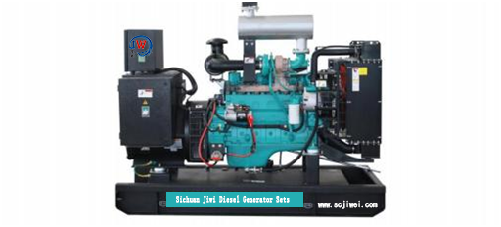

ESP  StandbyPower | 102kVA | PRP  PrimePower | 94kVA
ENGINE | DCECCummins | ALTERNATOR | STAMFORD
ENGINE | 6BT5.9-G1 | ALTERNATOR | UCI274C1

GENERALFEATURES
Engine:DCECCummins 6BT5.9-G1 | Alternator: singlebearing,IP23,insulationclassH
50℃ radiator, fansaredrivenbybelt, withsafetyguard | Drytypeairfilter, fuelfilter&oilfilter
Vibration damper | Standard controlpanel
24V chargingalternator | Exhaustbellows, elbows, flange &muffler
Lead-acidbatteries,rack and cables | Usermanual

MODEL:JW-C103400V |1500rpm |50Hz

GENERATORRATINGS
PF
（COSΦ)
StandbyAmps
StandbyRatings
(kW /kVA)
Voltage
Hz
Phase
440/254 50 3 0.8 135 82/102 75/94
415/240 50 3 0.8 143 82/102 75/94
400/230 50 3 0.8 148 82/102 75/94
380/220 50 3 0.8 156 82/102 75/94
PrimeRatings(kW /kVA)

PrimePower (PRP):Prime power is available for anunlimitednumberofannualhoursinvariableloadapplication,inaccordancewithGB/T2820（eqvISO 8528）;A 10% overloadcapabilityisavailableforaperiodof1hourwithin a12-hourperiodofoperation.
StandbyPowerRating(ESP):Thestandbypowerratingisapplicableforsupplyingemergencypowerforthedurationofautilitypowerinterruption.Nooverload,utilityparallelornegotiatedoutageoperationcapabilityisavailable atthisrating.

SALESPROMISES

JiweiPowerprovides a fullline of brandnew andhighqualityproducts.Eachandeveryunitis strictlyfactorytested.
Warrantyis according to our standard conditions:15months from thedateJIWEI sold tothefirstbuyeroroneyearafterinstallationor1000runninghours(accumulated),whichevercomesfirst.
Service andparts are available fromJiweiPower or distributorsinyourlocation.

MODEL:JW-C103400V |1500rpm |50Hz

ENGINESPECIFICATION
Manufacturer /Model | DCECCummins6BT5.9-G1
Airintake system | Turbocharged
Fuel system | A type fuelpump
Cylinder arrangement | 6inline
Displacement | 5.9L
Bore andstroke | 102*120（mm）
Compressionratio | 17.3:1
Rated speed | 1500rpm
Max. Standbypower atratedspeed | 92KW/123HP
Governor type | RSVMechanical

Exhaust System
Exhaust gas flow | 16.3m3/min
Exhaust temperature | 510℃
Maxbackpressure | 10kPa
Air IntakeSystem
Maxintakerestriction | 6kPa
Combustion air flow | 6.2m3/min
Air flowrequired for radiator | 158m3/min

MODEL:JW-C103400V |1500rpm |50Hz

Fuel System
Fuelconsumption@100%(PrimePower)Load | 208 g/kWh | 20.8L/h
Fuelconsumption@ 75%(PrimePower)Load | 209 g/kWh | 15.6L/h
Fuelconsumption@ 50%(PrimePower)Load | 221 g/kWh | 11.1L/h

OilSystem
Total oilcapacity | 16.4L
Oil consumption | ≤4g/kwh
Oil sumpcapacity | 12.3~14.2L

Cooling System
Coolant capacity | 27L
Max water temperature | 104℃

MODEL:JW-C103400V |1500rpm |50Hz

ALTERNATORSPECIFICATION
IndustrialalternatorsmeettherequirementsoftherelevantpartsoftheBS5000, VDE0530,NEMAMG1-22,IEC34, CSA 22.2-100 andAS1359.
Alternator Data
Number ofPhase | 3
Connecting Type | 3Phaseand 4 Wires, Ytypeconnecting
Number of Bearing | 1
PowerFactor | 0.8
Protection Class | IP23
Altitude | ≤1000m
Exciter Type | Brushless exciting
InsulationClass/TemperatureRise | H/H
TelephoneInfluenceFactor(TIF) | ＜50
THF | ＜2%
Alternator Capacity | 100kVA
Alternator Efficiency | 90.3%

MODEL:JW-C103400V |1500rpm |50Hz

GENERATINGSETDATA
Relatedrange of voltage setting | ≥±5%
Steady-state voltage deviation | ≤±1%
Transientvoltagedeviation(100 % suddenpower decrease) | ≤+25%
Transient voltage deviation(suddenpowerincrease) | ≤-20%
Voltagerecoverytime (100% suddenpowerdecrease) | ≤6S
Voltagerecovery time (suddenpowerincrease) | ≤6S
Relatedrange of frequency setting | 0-5% adjustable
Steady-state frequencyband | ≤1.5%
Transientfrequencydeviation(100 % suddenpower decrease) | ≤+12%
Transient frequency deviation(suddenpowerincrease) | ≤-10%
Frequencyrecoverytime(100 % suddenpower decrease) | ≤5S
Frequencyrecovery time (suddenpowerincrease) | ≤5S

STANDARDFEATURES
Standard auto controlsystem | Exhaust system(includinguntilmuffler) | Documents
Oil drainvalve | Startingbatteries (maintenance-free& watering-free) with connective  wires | Special tools
Base fueltank | MCCB

MODEL:JW-C103400V |1500rpm |50Hz

OPTIONS
Daily fueltank | Rainproof type | Remote controlpanel
Alternator heater | Soundproof type | Paralleling system
Spareparts | Trailer type | Switchbox
Automatic transfer switch

DIMENSIONS&WEIGHT
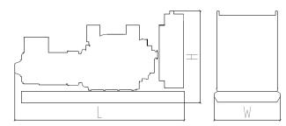 | Standard Configuration (open type withbasefueltank)
 | OverallDimensions: 2200×900×1700mm
 | Weight:1230kg
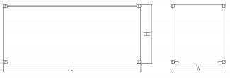 | Soundproof Type
 | OverallDimensions: 2810×1140×1830mm
 | Weight:1700kg

Specifications are subject to changewithoutnotice.

Sichuan Jiweicheng Electric Power Equipment Co., LTD.
Website :www.scjiwei.com
Whatsapp/WeChat:+86 18981714166
https://scjiwei.en.alibaba.com
Email :jiwei166@scjiwei.com
Address: Building 7, Chengnan Tianfu Wisdom Garden, Pengshan District, Meishan City, Sichuan Province

